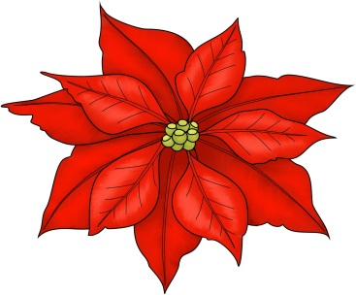
Poinsettia Sale

#__________SMALL –$ 5.00
- 4.5” pot, 1 plant/pot
- 2-4 blooms
- RED OR WHITE ONLY (circle one)

Choose Red, White, Pink or Varigated:

#_________MEDIUM - $8.00
- 6” pot, 1 plant/pot
- 4-6 blooms
_________________ - Poinsettia Color

#_________LARGE – $10.00
- 7” pot, 2 plants/pot,
- 8-10 blooms
__________________- Poinsettia Color

Email ckrjames@gmail.com with quantity, size, and color before Dec 4th. Mail payment by Dec 2nd to: Carol James at 3 Crisswell Ct, Sterling, VA 20165 or drop off in the Parish office. Checks should be made out to Carol James.

Name:___________________________
Email:___________________________
Phone:___________________________
Total: ______ $_______

Poinsettias will available for pickup at the
Christmas Market on December 6th.
All proceeds go to Christians of the Holy Land.

