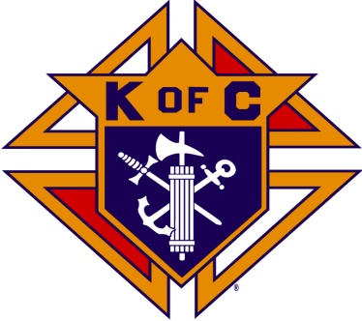
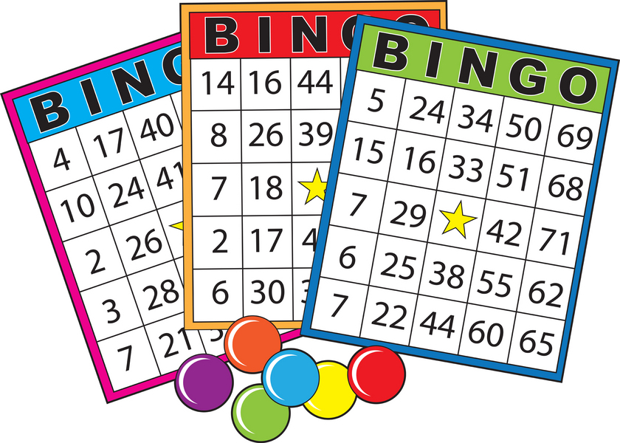

BINGO FOR BIRTHRIGHT OF LEESBURG
40TH ANNIVERSARY
Birthright in an international non-profit organization dedicated to helping women facing unplanned pregnancies have their babies.
WHEN: SATURDAY OCTOBER 25, 2014
WHERE: OUR LADY OF HOPE CATHOLIC CHURCH PARISH HALL
46639 ALGONKIAN PARKWAY, POTOMAC FALLS, VA
TIME: 7:00 PM TO 9:30 PM
COST: $20 FOR 16 GAMES/TICKETS SOLD AT THE DOOR STARTING AT 6:30 PM
PRIZES: FOR EACH OF THE 16 GAMES
Beer and wine will be sold at a nominal cost along with various snack foods. Sodas and water will be provided. PLEASE JOIN US FOR THIS FUN EVENT WITH ALL PROCEEDS GOING TO BIRTHRIGHT OF LEESBURG AND HELP A VERY WORTHY CAUSE SAVING OUR CHILDREN

