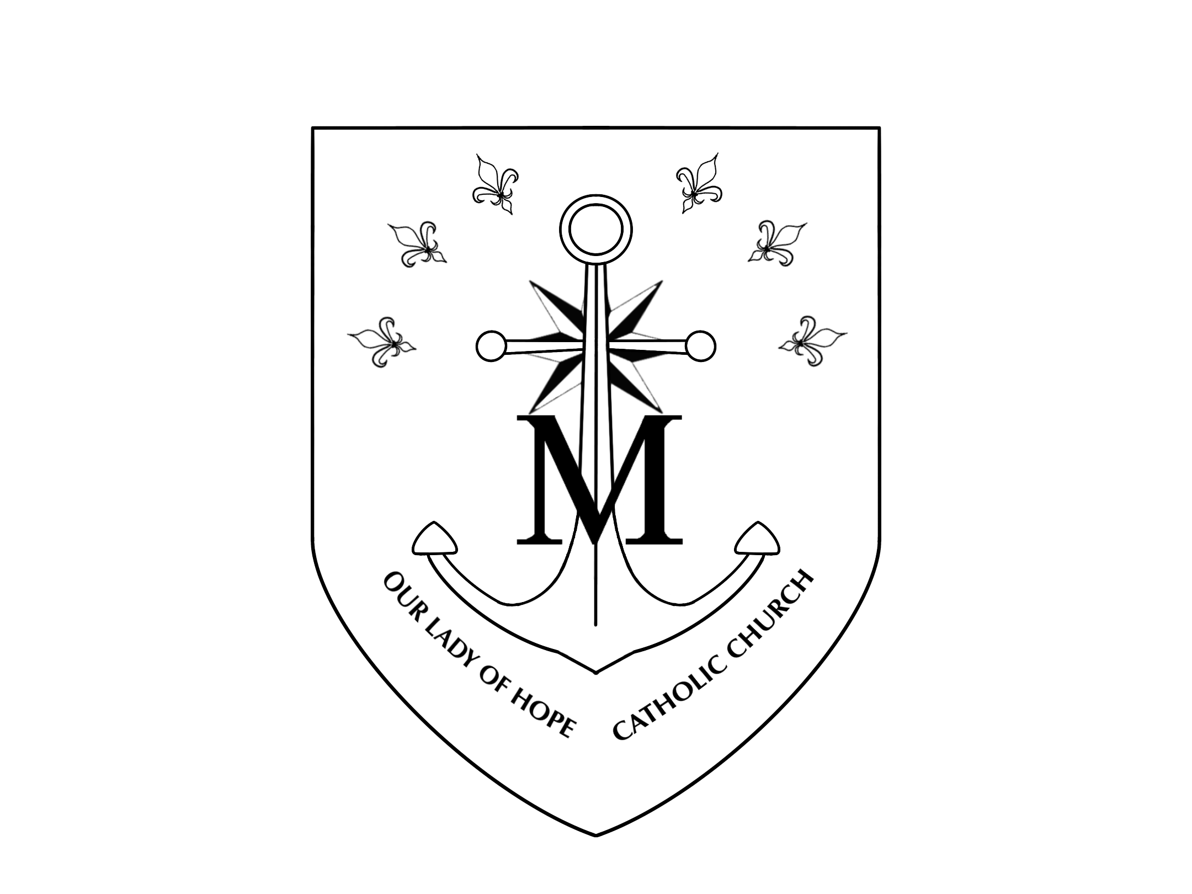
GODPARENT CERTIFICATE FOR THE SACRAMENT OF BAPTISM
This is to certify that I, , a registered member of

, accept the invitation to be a Godparent for the
(Name of Parish, City and State)
Baptism of _ at _.
(Parish of Baptism, City and State)

Date of Baptism:__________________________________
In accepting this responsibility I truthfully state before Almighty God all the following:

- I am at least 16 years old.
- I have received the Sacraments of Baptism, Holy Eucharist and Confirmation in the Catholic Church.

If married, I was validly married in the Catholic Church or with the Church’s permission
- I attend Mass regularly on Sundays and Holy Days of Obligation (unless prevented by sickness or emergency), receive the Sacraments of Penance and Holy Eucharist at least once a year, and profess the teachings of the Catholic Church.

I understand and accept the responsibility which I undertake as a Sponsor, I promise to be a support and example to this person in his\her efforts to live a Catholic life that reflects the spirit and teaching of the Roman Catholic Church. I am also prepared to assist the parents in their Christian duty by my support, encouragement, and prayer.

SPONSOR SIGNATURE
PRIEST’S CERTIFICATION

This is to certify that the above signed individual is a registered member of this parish in good standing; makes a contribution of time, talent, and treasure to the mission of the Church; and, to the best of my knowledge, is capable of assuming the duties and responsibilities of the role of Sponsor.

Pastor / Parochial Vicar

Parish

Date Received PARISH SEAL (must be present)

