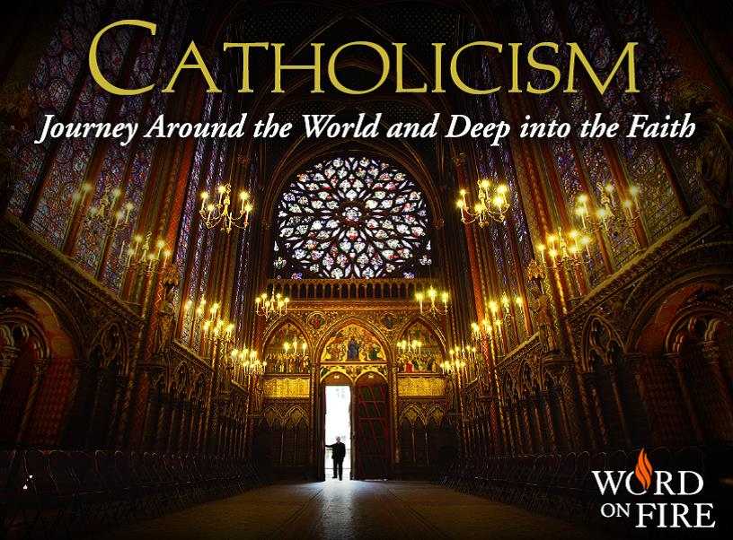
The Catholicism series with
Fr. Robert Barron

With Q&A after each presentation by our priests
and deacon

Wednesday Evenings
7:30pm to 9:00pm

In the Parish Hall

Come as often as you can for a for a Great Summer Refresher!
Brings your friends and relatives
This is a great series for anyone who wants to know more about the Catholic Faith.

July  2 | Episode I: “AMAZED AND AFRAID:  THE REVELATION OF GOD BECOME MAN”
9 | Episode II: "HAPPY ARE WE: THE TEACHINGS OF JESUS"
16 | Episode III: "THAT THAN WHICH NOTHING GREATER CAN BE THOUGHT:  THE INEFFABLE MYSTERY OF GOD”
23 | Episode IV: “OUR TAINTED NATURE’S SOLITARY BOAST:  MARY, THE MOTHER OF GOD”
30 | Episode V: “THE INDISPENSABLE MEN:  PETER, PAUL AND THE MISSIONARY ADVENTURE”
August  6 | Episode VI:“A BODY BOTH SUFFERING AND GLORIOUS:  THE MYSTICAL UNION OF CHRIST AND THE CHURCH”
13 | Episode VII: "WORD MADE FLESH, TRUE BREAD OF HEAVEN:  THE MYSTERY OF THE LITURGY AND THE EUCHARIST”
20 | Episode VIII: "A VAST COMPANY OF WITNESSES:  THE COMMUNION OF SAINTS"
27 | Episode IX: “THE FIRE OF HIS LOVE:  PRAYER AND THE LIFE OF THE SPIRIT”
Sept.  3 | Episode X: “WORLD WITHOUT END: THE LAST THINGS”

