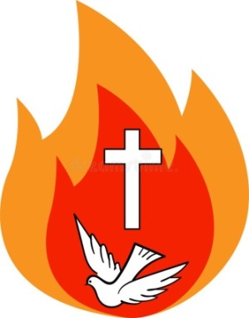
IMPORTANT DATES
for Confirmation Class of 2022

2021

September 1, 2021 Summer Workbook due

September 12, 2021 Begin weekly Sunday Mass readings reflections
(submit via Flipgrid)

2022

January 3, 2022 Saint Report Due
(OLOH school students follow instructions and deadline
from school religion teacher)

Administrative Fee ($125 to Our Lady of Hope)
Sponsor Eligibility Certificate (with Parish seal)
Candidate Sponsor Interview (handwritten on separate page)

February 12, 2022 Confirmation Exam (Parish Hall, 10 am-12 pm)
Service Proposal form due

July 31, 2022 Complete 10 Service Hours
Final Service Presentation due

Confirmation Retreat and Rehearsal: Usually the Saturday before the Liturgy.

Sacrament of Confirmation: Confirmation will be conferred in the Fall of 2022, usually in September. The Diocesan Chancery Office sets this date. You will be notified as soon as we receive this date (generally in January).

