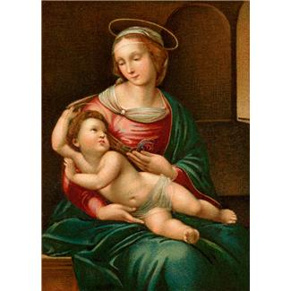
Join the growing
Junior Legion of Mary!
Through weekly meetings and assignments you can deepen your Catholic faith and grow closer to Jesus through His Mother Mary. Join us to be part of a faith group of children who work to help others and share the one, true faith.

Where: St. Elizabeth Ann Seton Meeting Room
When: Tuesdays after school (till ~4:30 pm).

For more information feel free to question Fr. Schierer

