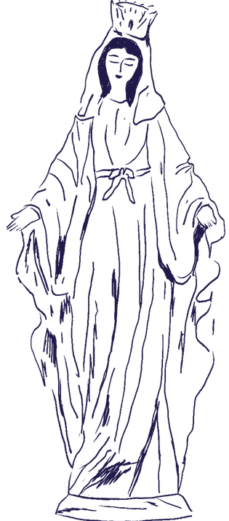

## Junior Legion of Mary

Participant Form

**When: Tuesdays from 3:15 PM – 4:30 PM Where: St. Thomas More Room (Parish)**

For your child to participate in Junior Legion of Mary, this form must be returned

to Mrs. Teresa Sargurudoss or Mrs. Cynthia Decker. You may email the form or leave a completed copy here. Please plan on picking up your child at the St. Thomas More Room at 4:30 PM. Communicate participation with your child’s teacher and Mrs. Angela Matzke.

# Child’s Name Grade

# Email contact:

Mother Cell:

Father Cell:

By signing below, you grant permission for your child(ren) to be escorted from OLOH School to the activity at the parish by an adult member of the Junior Legion of Mary after school.

Parent Signature:

### Program Contact:

Mrs.Teresa Sargurudoss & Mrs. Cynthia Decker

| [jrlegionofmaryoloh@gmail.com](mailto:jrlegionofmaryoloh@gmail.com)

| C. 703-270-8975

Important! If your family makes alternate plans for a day, please notify Mrs. Sargurudoss, the School Office, and your child’s teacher.