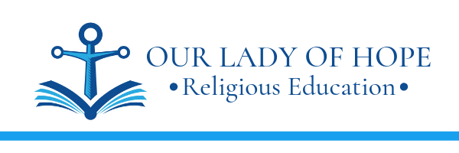

September 13, 2022

Dear Parents and 2024 Confirmandi (7th grade students),

These are the requirements for Confirmation at OLOH for this coming year.

- Weekly Gospel Reflections begin on the weekend of September 24/25, 2022.
You will receive weekly emails with a reflection prompt. Write a reflection based on the prompt and submit it (weekly) either via email or paper copy to your Catechist. The reflection should be a minimum of 5 sentences and be a thoughtful response to God’s Word.

- Application and Policy forms, copy of Baptismal certificate, due January 3, 2023.

- Submit Service Proposal Form(s) by January 3, 2023.
Students will select a project or events to serve and complete one service proposal form for each type of service. For example, volunteering as an usher at Mass and for Pancake Breakfast requires TWO service proposal forms. The forms are to be completed and approved prior to completing the service. The service needs to benefit someone in need who is outside of your family. See the service flyer for more details.

- Letter of Intent to the Pastor, due April 18, 2023.
Students will write a personal, handwritten letter to the Pastor indicating the intent to receive the sacrament of Confirmation. See instructions for more details.

- Complete 10 Service Hours and submit Final Service Presentation, due July 31, 2023.
See the included flyer for more details regarding the service presentation.

God bless,

Jackie Regan

