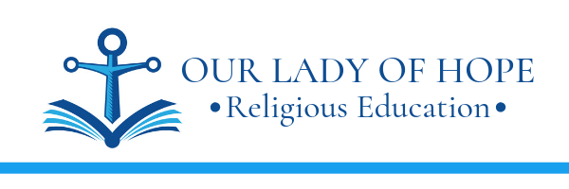

September 30, 2021

Dear Parents and 2023 Confirmandi (7th grade students),

These are the requirements for Confirmation at OLOH for this coming year.

- Mass Reflections begin on October 17, 2021.
Students will reflect on the Sunday Gospel readings and submit a 1-paragraph (minimum 5 sentences), type-written thoughtful response to a prompt. The reflection may be submitted to the teacher or can be emailed to acristofaro@ourladyofhope.net.

- Submit Service Proposal Form(s) by December 14, 2021.
Students will select a project or events to serve and complete a service proposal form for each type of service. This is to be done prior to completing the service. Not all proposals will be approved. The service needs to benefit someone in need who is outside of your family. See the service flyer and sample forms.

- Application and Policy forms, copy of Baptismal certificate, due January 25, 2022.

- Letter of Intent to the Pastor, due April 19, 2022.
Students will write a personal, handwritten letter to the Pastor indicating the intent to receive the sacrament of Confirmation. See instructions for more details.

- Complete 10 Service Hours and submit Final Service Presentation
See the included flyer for more details. (Note: The service Log is no longer needed. It is replaced by the proposal form and the final presentation.)

God bless,

Jackie Regan

