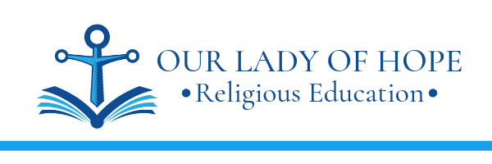

46639 Algonkian Parkway
Potomac Falls, VA 20165
(703) 433-6564

September 30, 2021

Dear Parents,

Your child is preparing to receive for the very first time the Sacraments of Penance and Holy Communion. Enclosed is a packet of information regarding the preparation process over the coming year. Please mark your calendar for the important mandatory dates listed on the following pages.

We are happy to be working with you in helping your child come to a deeper faith in Jesus Christ and His Church. The Church teaches that as parents you are the primary religious educators of your children. We cannot replace you, but we are delighted to help you. Please give us a call if you have any questions.

May God bless you,

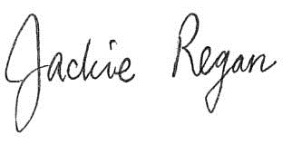

Jackie Regan
Director of Religious Education

Application and Preparation Policy Agreement
These forms indicate to the Pastor your desire to have your child prepare for and receive the Sacraments of Penance and Holy Communion. By reading the agreement and signing your name, you affirm that you will abide by the program policies and requirements. These forms are due December 7, 2021.

Administrative Fee
A fee of $100 is charged to cover the costs associated with the retreats, certificates, parish gifts and reception. The fee is due on December 7, 2021.

Baptismal Certificate
A copy of your child’s baptismal certificate needs to be on file at the RE office by December 7, 2021. If your child was baptized at Our Lady of Hope, simply indicate the approx. date on the application form and RE staff will obtain a copy of the certificate from the Parish files. Likewise, if your child attends the OLOH school, RE staff will obtain a copy of the certificate from the School files. If you do not have your child’s baptismal certificate, contact the church of baptism for a new certificate as soon as possible.

Religious Education Classes
Religious Education Classes are a vital part of preparation for reception of the Sacraments. Children are required to attend Religious Education classes on a weekly basis and to pass the assessments given prior to each Sacrament. More than five unexcused RE absences may delay reception of the Sacraments until the following year. OLOH School children will follow the requirements outlined by the School.

Workbooks on the Sacraments
Each student will receive a Penance Workbook and a Holy Communion Workbook. These workbooks are designed for you to complete with your child at home. The Penance Workbook is due February 15, 2022, and the Communion Workbook is due on April 19, 2022.

COLLECTION OF HOLY CARDS – Sundays and Holy Days of Obligation
Sunday Mass is the "Source and Summit" of our Catholic faith. Attending Mass as a family is the greatest gift you can give to your children. Your child will collect a Holy Card at Mass each Sunday and Holy Day of Obligation. After Mass at OLOH, approach the priest in the Narthex and politely ask for your Holy Card. It will have your name on it. At the end of the year, you will have a nice collection of holy cards. You will be given a card holder to keep your holy card collection. Prior to the Sunday Mass, your child’s teacher will give a lesson on the particular saint associated with the holy card. This will make getting the card more meaningful and memorable to your child. Begin picking up holy cards the weekend of October 17, 2021.

If you attend Mass at a church other than OLOH, submit a bulletin (with your name on it!) from that church to your teacher or to the parish office. You may exchange the bulletin for your holy card if desired.

My school worx

Parents will have access to a parent portal similar to ParentVue (used in LCPS) and PowerSchool (used at OLOH) called My School Worx. This portal will be used to monitor submission of sacramental requirements such as Mass Forms and Penance & Communion Workbooks. This will allow you to track what has been received by the RE office. You will receive a login email once your account is set up by RE staff.

Prayers to be Taught
Several prayers are reviewed and emphasized in class during this important year. Please assist your child with the memorization and understanding of these prayers: Hail Mary, Our Father, Glory Be, and the Act of Contrition. Additionally, the Sign of the Cross and genuflection must be done correctly.

First penance & first communion tests
There will be a written test and oral prayer assessment 2-3 weeks prior to reception of each of the Sacraments to ensure readiness. Flashcards and other study aids will be available for use in class and at home.

Retreats for Children
There will be a Penance Retreat on March 19, 2022 and a Communion Retreat on April 30, 2022, both in the morning for 2 hours. These retreats are mandatory.

Retreats for Parents
There will be a Penance Retreat for Parents on February 5, 2022 in the morning for 2 hours. There will also be a Communion Retreat for parents (TBD). These retreats will help you to better understand the sacraments so that you are well prepared to help your child.

First Penance
The example of parents and other adults receiving the Sacrament of Reconciliation, in joy and with meaning, teaches the child to appreciate this opportunity to seek God's forgiveness, and to deepen his or her relationship with Him. A child's desire to receive the Sacrament of Penance will depend greatly upon the degree of importance his/her family places upon this Sacrament.

Please help prepare your child for confession by going over the Ten Commandments, an examination of conscience, the Act of Contrition, and how to make a good confession. The Act of Contrition and the form of the Sacrament must be memorized.

The Sacrament of Penance will take place immediately after the Penance Retreat for Children. Families are invited and encouraged to go to Confession at this time, as an example to your child.

First Holy Communion Mass
The First Holy Communion Mass will be May 7, 2022 at 11 am at OLOH.

Important Dates to Remember
Please mark these dates in your calendar.

Collect Holy Cards Weekend of October 17, 2021

Application, Baptismal Due December 7, 2021
Certificate, Fee

First Penance Retreat for Parents: February 5, 2022

Penance Workbook: Due February 15, 2022

Penance Test March 1, 2022

First Penance Retreat for Children: March 19, 2022

Reception of First Penance: March 19, 2022 immediately following the Retreat

Holy Communion Workbook: Due April 19, 2022

First Communion Test April 26, 2022

First Holy Communion Retreat
for Parents: (To be determined)

First Holy Communion Retreat
for Children: April 30, 2022

First Holy Communion Mass: Saturday, May 7, 2022 at 11:00 am.
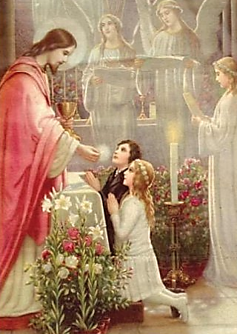
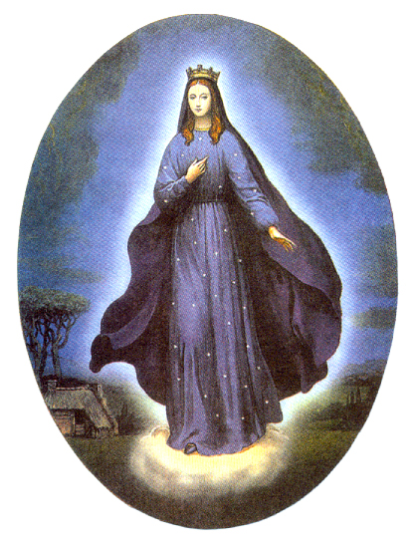
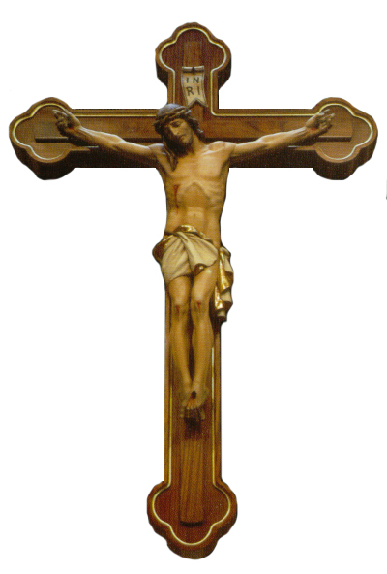
First Penance &
First Holy Communion
Our Lady of Hope Parish
Application

Name of Child: __________________________________________________________________________

Date of Birth: _____________________________ Place of Birth: ________________________________

Home Address: __________________________________________________________________________

City: _____________________________________ State: _______________ Zip: __________________

Father’s Name: _____________________________ Mother’s Name: ________________________________

Record of Baptism **

Church of Baptism: _______________________________________________________________________

City: _____________________________________ State: _______________ Zip: __________________

Date of Baptism: ____________________________ Mother’s Maiden Name: ________________________

** Submit a copy of your child’s Baptismal Certificate by December 7, 2021.

If your child was baptized here at Our Lady of Hope, indicate the date on the application form and RE staff will obtain a copy of the certificate from the Parish files. Likewise, if your child attends the OLOH school, RE staff will obtain a copy of the certificate from the School files.

Our Lady of Hope Catholic Church
First Penance and First Holy Communion

Preparation Policy Agreement

I will make every effort to participate fully in my child’s preparation for these Sacraments, specifically:

- I will help with my child’s religious education assignments and overall sacramental preparation at home.
- I will send my child each week to Religious Education class on time and for the entire class period; if my child is absent more than five times without a valid reason or my child fails to obtain a 70% or greater on the assessments (Midterm, First Penace and First Communion), the reception of the Sacraments may be delayed. OLOH School children will follow the requirements outlined by the School.

- I will take my child to Mass each Sunday and on Holy Days of Obligation.

- I will assure my child’s attendance at First Penance, which must be received before First Communion.

- I will assure my child’s full participation in the First Penance and First Holy Communion Retreats.

- I will, to the best of my ability, attend the Penance and Communion Retreats for Parents.

Failure to complete the above requirements may delay my child’s reception of these Sacraments for this school year. However, the Sacraments will be administered later when my child and I can complete these requirements.

Date_____________

________________________________________
Parent’s Signature

________________________________________
Printed Name

________________________________________
Child’s Name (Print)

