Our Lady of Hope Catholic Church
Religious Education Handbook
2021-2022



Office of Religious Education 703-433-6770
46639 Algonkian Parkway 703-433-6564
Potomac Falls, VA 20165
www.ourladyofhope.net jregan@ourladyofhope.net
M – Th, 9 AM – 4 PM acristofaro@ourladyofhope.net

Dear Parents,

Welcome to the Religious Education Program of the Our Lady of Hope Parish. The RE staff, Father Killian, Father Willard, volunteer Catechists and Aides thank you for entrusting your children to our care. We take very seriously the responsibility of teaching the truths of our Catholic faith, both in words and in deeds. United with your dedication to and sharing of our Catholic faith, we strive to provide an environment where your children can come to know, love, and serve Our Lord.
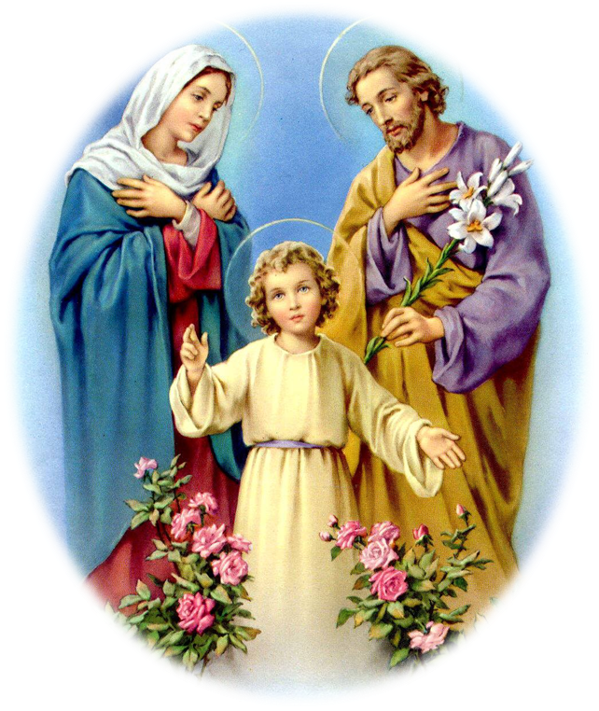
This Religious Education Handbook will assist you throughout the year in understanding our program and policies. Please feel free to contact us at the Religious Education Office with any questions or concerns you may have.

Let us pray for Christ's blessings on our Catechetical efforts. May God Bless you and your families as you strive to imitate the Holy Family.

In Christ's Love,

Jackie Regan
Director of Religious Education

Religious Education Mission Statement

We strive to present the doctrine of the Catholic faith in its fullness and entirety as both knowledge to be learned and as life to be lived, with the ultimate objective being to help parents and children know, love, and serve God so as to find eternal life and happiness with Him forever in Heaven.

Our goals, in addition to educating children in the faith, are to:
Support families in their journey towards sanctification and salvation;
Build community among parishioners;
Encourage an attitude of service in the RE families and the parish in general;
Develop a missionary spirit that, emboldened by the Holy Spirit, will help us live out the Great Commission, to go and make disciples of all nations.

Key elements of the program involve the following:
Parents are recognized and respected as the primary educators of their children.
Parents are supported in their role by making available small groups for discussion, given opportunities to receive the Sacraments as a family, and fostering a sense of community both within the Religious Education program and the wider parish as a whole.
The doctrine of the Catholic faith is presented in its fullness and entirety.
The importance of the Holy Mass and the Eucharist is emphasized as the “source and summit of Christian life” (CCC1324).
The frequent reception of the Sacrament of Penance as a family is encouraged and incorporated into the program.
Devotion to Our Blessed Mother, as the first disciple of Jesus, is part of each class.
Prayer, at the start and end of each class, is taught and developed as vital to growing closer to God.
Studying the lives of the saints is encouraged as role models and patrons.
The virtues are taught and practiced in everyday life.
A spirit of service is encouraged and provided by offering service projects throughout the year, especially the Advent and Lenten parish-wide service projects.

Role of Parents
It is the role of the parish to assist parents in nurturing the faith of their children. Parents are encouraged to approach the staff with ideas to meet specific needs in raising healthy and holy Catholic children.

It is the role of the parents to work with and support the RE staff and Catechists in their efforts. Parents are asked to fulfill the following expectations in order to promote the faith of the children and to ensure a quality program.

A parent who would like their child to attend the program is expected to:

- Be a registered member of a parish.
- Be responsible for providing the parish with information regarding your child’s baptism and other sacraments, if applicable.
- Attend Sunday Mass weekly with your child.
- Take responsibility for your role as primary educator of the faith.
- Collaborate with the catechist by sharing the faith at home and by making sure your child completes any required assignments or homework prior to each class.
- Teach your child the traditional prayers of the Church.
- Maintain an open line of communication with your child’s catechist.
- Make sure your child attends class on a regular basis, and inform the catechist when and why there is an absence.
- Be punctual in bringing your child to class. This means your child being settled and ready to learn at the start of class.
- Bring your child to class dressed appropriately for the weather.
- Ensure that your child’s classroom behavior is acceptable and conducive to learning for all students.
- Be supportive of the catechist, especially in the area of discipline.
- Attend parent meetings when requested.
- Read this handbook, complete and turn in the forms necessary for registration.
- Inform the religious education staff of the rights of the non-custodial parent in the case of divorce. This is essential to ensure that the program acts in the best interest and safety of the child.
- Inform the Religious Education staff of any pertinent medical and emergency information.

Role of Students

It is essential that students cooperate with the catechists and aides, as well as the RE staff. Students are asked to fulfill the following expectations in order to ensure a quality program.

A student who attends the program is expected to:

- Be punctual and prepared for class each week. Arrive 5 minutes before class begins so that you are settled and ready to learn at the start of class.
- Arrive no earlier than 15 minutes prior to the start of class, and be picked up no later than 15 minutes after the end of class.
- Complete any homework and online assignments prior to each class.
- Respect your Catechists and Aides as teachers and role models.
- Conduct yourself in a manner appropriate to a classroom environment.
- Behave reverently when in the Church for the reception of Sacraments (e.g. Confessions), as well as during special Liturgies (e.g. Holy Hour).
- Remember that all property and possessions found in the classroom do not belong to you and are to be left untouched.
- Obey the No Food policy in the classroom. Exceptions are made for class parties organized by the Catechist.
- Enter and exit the building through the main school lobby, reserving the side doors for emergencies only.
- Do not bring electronic devices or other distractions to class, or keep them put away in your backpack. If used inappropriately and is a distraction to the class, they will be confiscated.
- Obey social-distancing, hygiene, and safety rules while on church property.
- Obey rules for online safety and distance learning.

Role of Catechists

Catechists play a unique role in helping people acquire and deepen their Christian faith. Catechists are asked to demonstrate the following characteristics:

- Promote knowledge of faith, the Liturgy and the sacraments.
- Promote moral formation in Christ.
- Teach how to pray with Christ.
- Prepare the Christian to live in community and to participate actively in the life and mission of the Church.
- Promote a missionary spirit.
- Be a role model of how to know, love, and serve God.

Classrooms

Religious Education classes will be held at the Our Lady of Hope School and online. There are nine classrooms in the building typically used by the RE Program: four on the bottom floor and five on the top. A map of the school building, including the classes assigned to particular rooms, will be distributed before the beginning of the program year. The map below shows a typical assignment of class locations. This may vary for certain sessions.

The restrooms located in the hallway near the classrooms are reserved for students only. Adults may use the restroom located in the Teacher’s Lounge on the first floor.

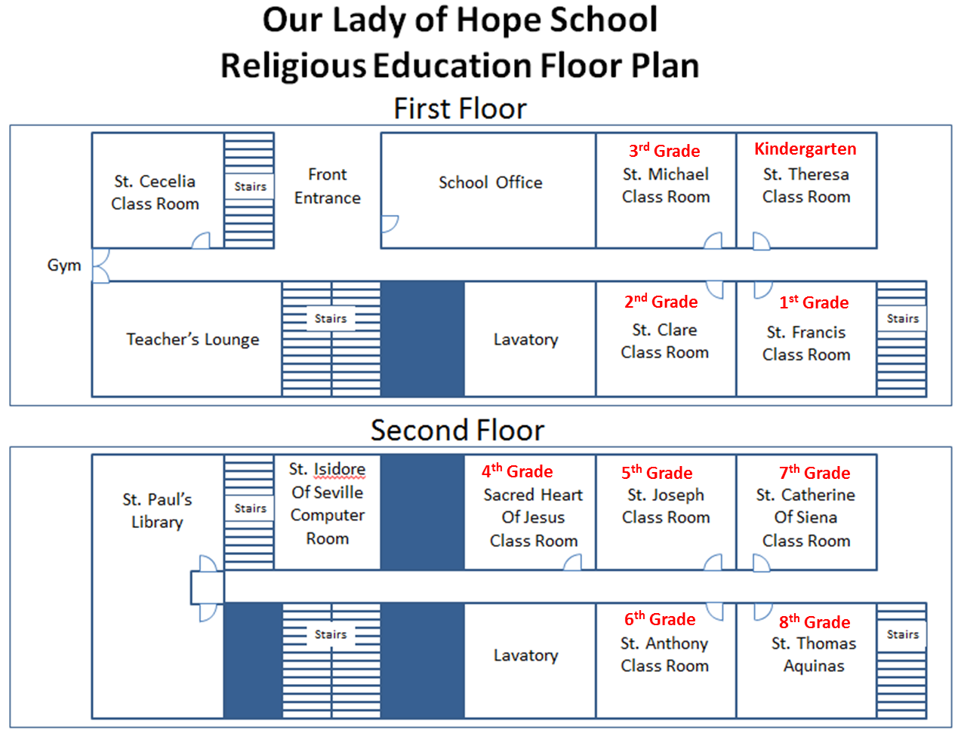

Arrival and Dismissal

  - Catechists, Aides, and Other Volunteers may park in the upper school parking lot closest to the school building.
  - Parents may park in the lower church parking lot.
- At the discretion of the parents, students in 5th through 8th grades may be dropped off and picked up in front of the school.
- During the winter months when classes may start and/or end when it is dark, please use extra caution in the parking lot.
- Parents of Kindergarten to 4th grade students must bring their child to the classroom and pick up their children at the classroom.
  - All students must enter and exit through the lobby only. No student will be able to exit through the gym or east side fire exits by the playground.
  - Children will not be permitted in the classrooms until a catechist or aide is present.
  - Carpools: Parents who plan to carpool with other families need to notify the catechist/aide, in writing, who is eligible to pick up their child from class and specify the date(s).
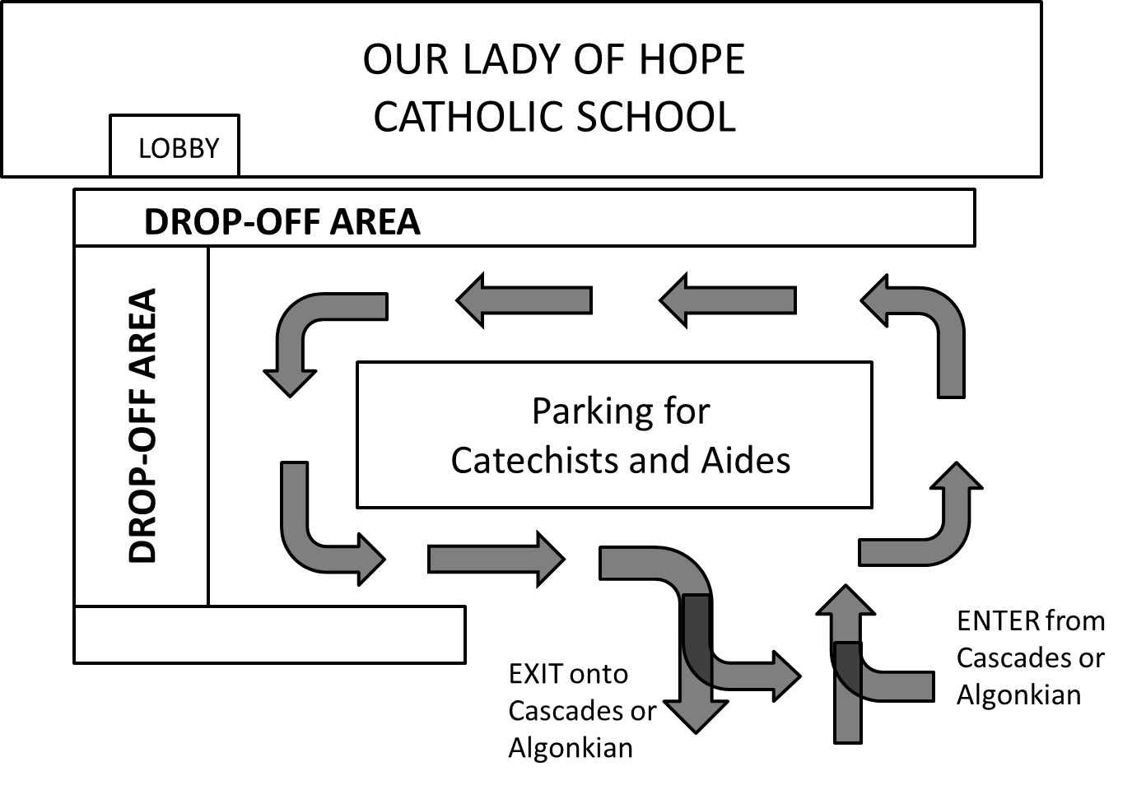

Class Assignments

The RE Program offers two class sessions:

Tuesdays 4:15-5:30 PM
Tuesdays 6:00-7:15 PM

Classes are assigned on a first-come, first-serve and need basis. To the best of our ability, siblings will be placed in the same session. Some classes may need to be cancelled due to low enrollment or lack of volunteers.

Basic grade-level knowledge of RE formation (e.g. prayers, understanding of the faith) will be required to enter the following grade. For example, a student must pass the 4th grade Final Exam to demonstrate readiness for the 5th grade curriculum.

Our Lady of Hope has a two-year sacramental preparation for First Holy Communion and Confirmation. First Holy Communion candidates must complete both 1st and 2nd grades to receive the sacrament. Confirmation candidates must complete both 7th and 8th grades to receive the sacrament.

Curriculum

Faith and Life Online (Ignatius Press) is used for 1st through 7th grades. The Ascension Press curriculum Chosen: Your Journey Toward Confirmation is used for 8th grade.

Faith and Life Online is used as a flipped classroom model, where students are expected to complete the assigned chapter(s) at home before class. This involves reading the chapter text online, taking the post-assessment test, and completing activities in the lesson designed to reinforce concepts. In class, the lesson will be reviewed and the additional class time will be used to engage children in discussion, complete hands-on activities, and focus on additional topics such as virtues, saints, prayer, and devotions to Mary.

Each grade level has a specific Diocesan curriculum guideline which contains the required basic instructional objectives for each grade and provides not only objectives but strategies as well. The Diocesan Curriculum Guidelines can be obtained from the Diocesan website at
http://www.arlingtondiocese.org/Catholic-Schools/Religion(1)/.

My School Worx is an online parent portal that allows parents access to their child’s homework grades, assignments, attendance, and other student data. For sacramental years, the portal data will also include requirements such as Mass attendance, forms, service hours, etc. With this program, parents are able to keep track of their child’s progress in the classroom as well as the status of sacramental requirements.

Prayers to Be Learned

Each class will begin and end with a prayer. The Diocesan Curriculum Guidelines assign basic prayers to be learned for each grade level. We strongly urge you to reinforce a life of prayer at home by praying the prayers found in the chart below with your child. It is crucial for students to learn these prayers in order to more fully participate in the liturgical life of the church. Each grade will review the prayers learned in the preceding grade. Prayers for 1st grade through the 4th grade midterm are evaluated orally. Prayers for the 4th grade final through 8th grade are written.
Grade | Prayers to Know (cumulative)
Kindergarten:  * No formal assessment | - Sign of the Cross  - Genuflection
Grade 1: | - Our Father  - Hail Mary  - Glory Be
Grade 2: | - Act of Contrition  - Form of Sacrament of Reconciliation  - Examination of Conscience  - Ten Commandments
Grade 3: | - Guardian Angel  - Prayer to St. Michael the Archangel  - Grace Before Meals
Grade 4: | - How to say the Rosary  - Fatima Prayer
Grade 5: | - Two Great Commandments  - Spiritual and Corporal  Works of Mercy  - Apostles' Creed  - Seven Sacraments  - Precepts of the Church
Grade 6: | - Mysteries of the Rosary  - Beatitudes
Grade 7: | - Seven Gifts of the Holy Spirit  - Four Marks of the Church  - Theological and Cardinal Virtues
Grade 8: | - * Confirmation Study Guide

Students are expected to know the prayers of the preceding grades. Midterm and Final exams are cumulative. Flashcards and Kahoot study aids are provided.

* Students in 8th grade are given a Confirmation Study Guide to aid in preparation for the Confirmation Exam.

Academic Calendar

The school year calendar for the Religious Education Program is emailed to families at the beginning of the year and available by request from the RE office. The calendar parallels closely, but not exactly, the Loudoun County Public Schools calendar. Please refer to the RE calendar for holidays, Holy Hour, and other special events.

Attendance/Absences

You must notify your child's Catechist if your child will be absent and the reason for the absence. Regular attendance is essential to the ongoing formation of your child. Student attendance will be taken at the beginning of every class. Students are expected to have no more than five unexcused absences per academic year. Excessive absences may result in a failure to progress to the next grade level and/or a delay in receiving the sacraments of First Penance, First Holy Communion, or Confirmation.

Homework Assignments

Parents are expected to assist their child with homework assigned by the Catechist. Failure to complete homework on a timely and regular basis may result in a failure to progress to the next grade level.

Assessment

The objective of testing is to monitor student growth and assess progress and effectiveness of our Religious Education Program. Parents who have concerns about their child’s progress should contact the Catechist or RE staff.

For promotion to the next grade level, the student must earn a 70% or higher for the class grade, as well as score at minimum of 70% on the midterm and final exams. The class grade will be based on the following: 80% from the Faith and Life Online post-assessment tests, and 20% from class activities/work. Exceptions – there is no formal assessment for Kindergarten, and 8th graders will be assessed using the Confirmation Exam and other catechist-assigned work.

Classroom Discipline

Students are expected to treat adults and peers, as well as private and Church property, with respect at all times. Furthermore, every child has the right to education in an environment conducive to learning. Thus, it is necessary to establish order in the classroom.
In the event that a student's classroom behavior is disruptive, the catechist should:
- Speak to the child in private (perhaps briefly stepping out of the classroom) and try to encourage the student to change their behavior;
- Avoid embarrassing the child in front of classmates;
- Enforce assigned seating from the very first day and physically separate students, as space allows;
- Talk to the parents, if necessary;
- If the student continues to be disruptive, send the student to the Director of Religious Education who will speak to the student.
- If this attempt is not successful, the parents will be contacted and asked to work with their child and the catechist to correct the behavior.
- If this does not help, the parent must accompany the student to class until the student’s behavior is acceptable for the classroom environment.
- If school or private property is willfully damaged by a student, he/she and parents will need to make appropriate restitution.

Dress Code

Students, as well as Catechists and Aides, are expected to wear modest clothing appropriate for the classroom, with particular emphasis on the days that Confessions and Holy Hour are scheduled. If a student violates this policy, his or her parents will be immediately notified. The parent will bring alternative clothes for the student to change into so that he or she may return to class.

Inclement Weather and Cancellations

If Loudoun County Public Schools cancels school for the day, dismisses school early due to inclement weather, or if county afternoon and evening activities are cancelled, then evening Religious Education classes are likewise cancelled. If there is a 2-hour LCPS delay, there will still be Religious Education classes that evening. If classes are cancelled by the parish for whatever reason, an email will be sent to each family as soon as possible. When in doubt contact the Religious Education Office at 703-433-6564.

Health Issues and Medication Policy

Should a student become ill while in class, parent(s) will be contacted according to the information provided on the registration form. Medications will NOT be administered to the child by RE staff or catechists.

Children are NOT to bring medications with them to religious education classes without advance permission of the RE staff. It is the responsibility of parent(s) to notify the RE staff immediately of any changes in allergies or dietary restrictions. For children with severe medical conditions, parents must remain on-site in case of emergency.

Catechists must report any significant injury to the RE staff immediately. If an injury occurs, first aid will be administered, and if deemed necessary the parent(s) will be contacted. If the injury requires immediate professional medical attention, RE staff will call the appropriate emergency services, followed by a call to the parent(s). A first aid kit is available in the school lobby as well as in each classroom.

Learning Disabilities / Health Related Problems
If your child has a learning disability or health-related problem, this information should be annotated on the child’s registration card. It will remain confidential, but this information will be passed on to the catechist to aid in the education of your child. The RE staff and Catechists will work with the parents to address any learning or behavioral challenges. Please call the Religious Education Office with concerns or questions.

Home-Schooled Students or Students Attending a Catholic School
The RE Program definition of Catholic home-schooled students are those being home-schooled in all academic subjects by their parents, not just religion. Home-schooling families are encouraged and welcomed to participate in our Religious Education Program. This is a wonderful opportunity to foster a sense of community within the parish and interact with other Catholic children in a controlled and caring environment.
Home-schooled students in sacramental grades (1st, 2nd, 7th, and 8th) are required to enroll in the Faith and Life Online class and complete the lessons throughout the year. The midterm and final exams for that grade will also need to be taken and passed with a 70% or better.
Home-schooled students and students enrolled in a Catholic school must formally apply and register to be enrolled in the parish First Communion or Confirmation class and must fulfill all sacramental requirements. Please contact the Religious Education Office for more information.

Security and Emergency Procedures

The school building will be secured during Religious Education classes. Side and emergency doors are locked at all times. All students, parents, and adult volunteers must enter and exit via the school lobby only. The school lobby is manned by the Religious Education staff. In the event the staff is unavailable, the lobby doors will be locked. If a child needs to be picked up early, arrangements should be made ahead of time and the catechist notified.
In case of emergency, the catechist’s main responsibility is the evacuation and safety of the children. There are established emergency procedures which will be practiced as drills during the year.

Sacraments and Liturgy

Children’s Holy Hour

An integral part of our Religious Education Program is the Children’s Holy Hour, which takes approximately 25 minutes of the class session. Please refer to the RE calendar for specific dates. Participation will include 2nd through 8th grades. Proper manner and dress in God’s house is stressed and reviewed prior to the Holy Hour. Parents are encouraged to attend. Children will return to the classroom for dismissal.

May Crowning

The Religious Education Program celebrates each May with a traditional May Crowning honoring Mary, the Mother of God. Each session will have its own May Crowning. Every child will present a flower to a statue of our Blessed Mother. Flowers are provided by the parish or may be brought by individual students if they wish. A Children’s Holy Hour is incorporated into the May Crowning program.

First Penance & First Holy Communion

First and Second grade Religious Education classes together constitute the two-year formation period for the receptions of First Penance and First Holy Communion. The sacrament of Penance is first received in February or March of 2nd grade. First Communion is typically received during May of that same year. Please call the Religious Education Office for more information.

Confirmation
Seventh and Eighth grade Religious Education classes together constitute the two-year formation period for the reception of the sacrament of Confirmation. Confirmation is typically received in the Fall of 9th grade. Please call the Religious Education Office for more information.

Catechist Profession of Faith
Catechists and Aides are a visible witness to the Catholic faith. By request of the Bishop, they are asked to make a Profession of Faith. This is a public proclamation of the principle truths of our Catholic faith expressed in the Nicene-Constantinopolitan Creed, together with the truths taught by the Church which are not contained in the Creed itself. All Catechists and Aides make this Profession of Faith: “I believe and profess all that the Catholic Church believes, teaches, and proclaims to be revealed by God. I promise to teach sincerely and fully, through both my words and actions, this same faith to those entrusted to my care.”

Diocesan Policy on Child Protection and Safety (for Volunteers)

The Diocese of Arlington has a policy to prevent child abuse and sexual misconduct. The website for the Diocesan Child Protection Office is http://www.arlingtondiocese.org/child-protection/. Volunteers who have significant contact with children are required by the diocese to comply with this policy. The safety and protection of all children is of paramount importance.

All RE volunteers and staff will comply with this policy. If you have questions or concerns, please contact the parish OPCYC liaison, Ashley Cristofaro, at (703) 433-6770 or acristofaro@ourladyofhope.net.

Diocesan Safe Environment Training

Formation in Christian Chastity, a curriculum used by the Diocese of Arlington for the mandatory Safe Environment Training, will be used for Grades 1-4. The Circle of Grace curriculum will be used for grades 5 through 7. Grade 8 will use the curriculum included in their Chosen textbook.
Parents may choose to opt-out of the lesson. The specific class day for teaching the program will be on the RE calendar. There will be a make-up day for those who were absent. If a child is opted out of in-class training, or if a child misses the in-class and make-up lesson, the parent is responsible for teaching the lesson at home.

In-Person Safety Precautions

All individuals – students and volunteers – are expected to wear a face mask when moving around the building. When seated at their desk and more than 6’ away from others, students may remove their face masks. Teachers and aides will wear a face mask at all times, except when teaching at the front of the room and more than 6’ away from others.

Online Classroom Learning

In case of need to move to online classes, the platform Zoom will be used. Attendance for online classes will be expected, as it would be for in-person classes. The camera must be ON during the entire class period to ensure proper engagement. Proper online etiquette must be observed on the part of both student and Catechist. Parents are invited to “sit in” on any class but must not disrupt the class.

Waivers

Due to the COVID pandemic, the Diocese of Arlington has required parents of in-person classes to sign a waiver. You will be given a waiver to sign and return before the start of classes.
.
Educational Resources for Parents and Catechists

There are flashcards, Kahoot and Quizlet links on the OLOH website to help students study for the midterm and final exams. In addition, the Catholic Education Center has courses that are available free of charge to parents and catechists in the Arlington Diocese. Contact RE staff for more details.

