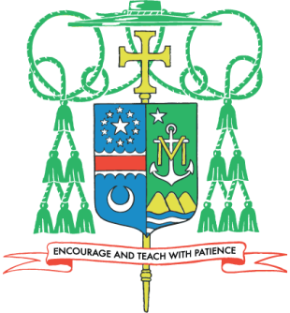

May 11, 2014

Dear Brothers and Sisters in Christ,
Grace and peace be with you!
I am writing regarding the care and support of our retired diocesan priests. As you may know, there are 170 diocesan priests faithfully serving Jesus Christ and our diocesan Church. Of these, 21 priests are retired currently, and over the next ten years 17 additional priests will reach retirement age.
To provide care for our current and future retired priests, the annual second collection for retired priests will take place next weekend, May 17 and 18, at all Masses. I ask you to consider participating as generously as you are able in next week’s collection.
The funds from this annual collection will assist the ongoing operational needs and expenses of the Saint Rose of Lima Priests Retirement Villa, a residence designed to accommodate retired diocesan priests. This beautiful and restful home includes both common areas and private residences for up to eight priests. Additionally, this second collection will provide funds for post-retirement health care, nursing home care, and the priest pension fund.
May the Risen Lord Jesus abundantly reward your goodness and fill you and those you love with His peace, hope and life! With gratitude for your generosity, I remain
Faithfully in the Heart of Christ,
Most Reverend Paul S. Loverde
Bishop of Arlington

